Internet Safety
Guide

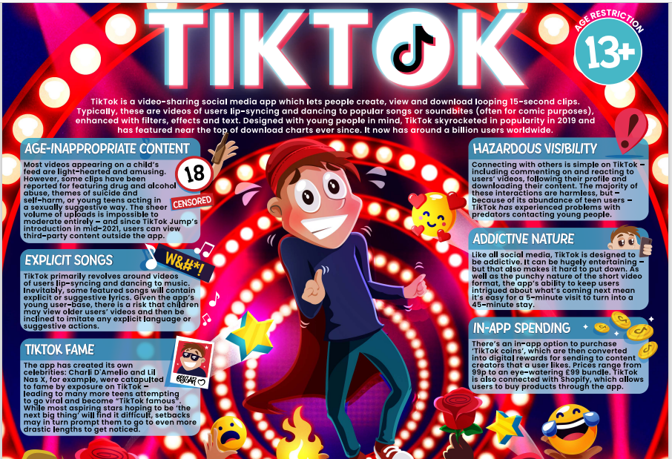

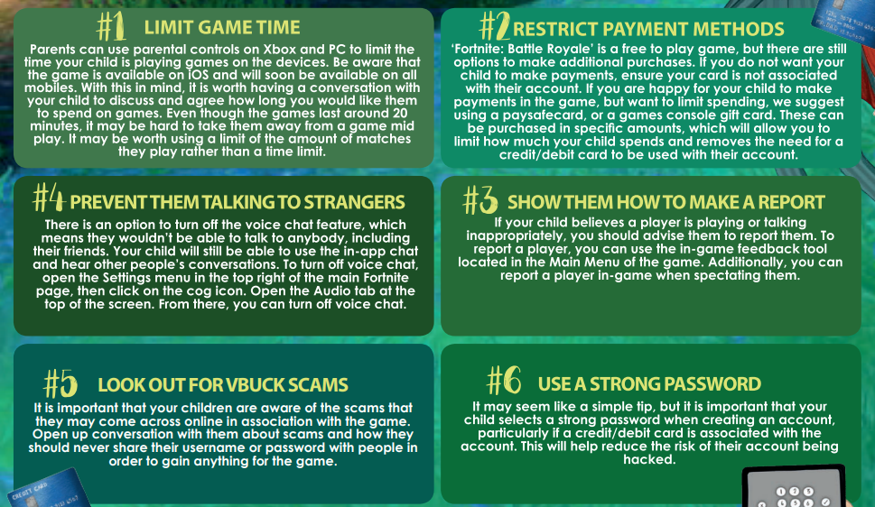
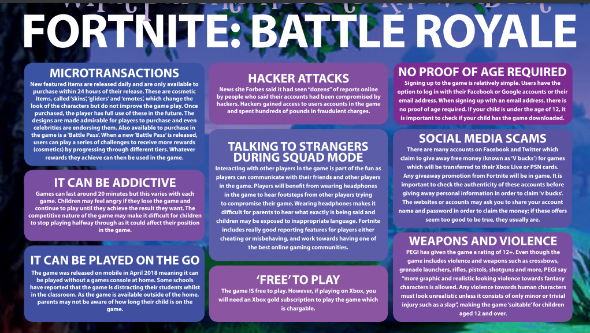

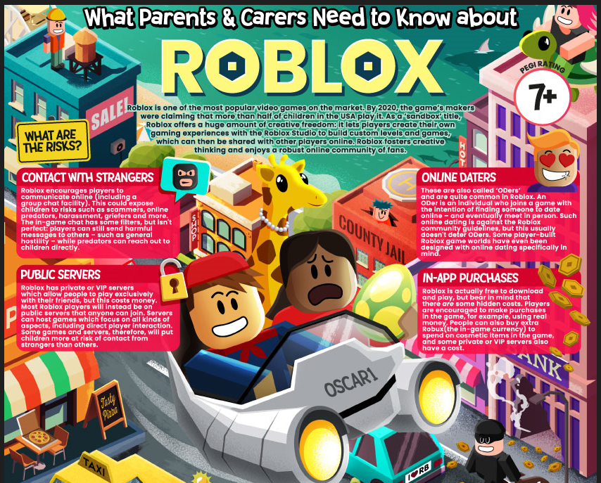

A very useful website that provides tips on how to set up parental controls to keep your children safe online.

KS1 Finding information on the Internet safely:

I know
- That I will get to use the internet if I use it responsibly
- That being responsible means I should not try to visit unsafe sites or register for things I am not old enough for
- The sites that are safe for me to use
- What to do if I open something that I don’t like
- How to search safely to find the information I want
- That I should be supervised
- That any information I put up on the web can be read by anyone
- That I should not copy others work and claim it as my own
Using technology to contact people:
I know
- How to keep my personal information private
- That I need to be polite online and friendly online and think about the language I use (it could be forwarded to my parents of head teacher!)
- What to do if I receive an message of email that I don’t like
- That people online many not be who they seem
Using technology for buying and selling:
I know
- How to tell the difference between web sites for information and web sites selling things
- That I should not use someone else’s identity to buy things online

KS2 Finding information on internet safety:
I know
- That I will get to use the internet if I use it responsibly
- That being responsible means I should not try to visit unsafe sites or register for things I am not old enough for
- That any protection system does not stop all unsafe content
- What to do if I open something that I don’t like
- How to search safely to find the information I want
- That I should be supervised
- That any information I put up on the web can be read be anyone
- That I should ask permission to use the work of others and credit them if I do
- That I should not copy others work and claim it as my own

Using technology to contact people:
I know
- How to choose my user name carefully to protect my identity
- How to keep my personal information private
- How to use safety features of web sites
- How to limit access to my information
- That e-mails / messages can be intercepted and forwarded on to anyone
- That I should be careful who I add as friends
- That I need to be polite online and friendly online and think about the language I use (it could be forwarded to my parents or head teacher!)
- How to use the subject field in e-mails
- Not to open messages if the subject field contains anything offensive or if I do not recognise who it is from (delete it without opening it)
- What to do if I receive an offensive message / e-mail including how to keep evidence
- That people online may not be who they seem

Using technology to for buying and selling:
I know
- How to tell the difference between web sites for information and web sites selling things
- How to recognise commercial uses of the internet e.g. I Tunes, mobile phone downloads, shopping
- That if an offer looks too good to be true it probably is
- That I should not respond to unsolicited online offers
- That I should not use someone else’s identity to buy things online

