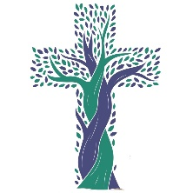
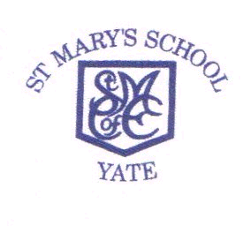
ST MARY’S C.E. PRIMARY SCHOOL
In Partnership with St Helen’s Primary School

Church Road,

Yate,

Executive Headteacher: Mrs J Simpson
Headteacher: Mrs Bethan Scriven
Deputy Headteacher: Mrs Natalie Lane
Date: May 2025

South Gloucestershire,
BS37 5BG
Telephone: (01454) 867155
Fax No (01454) 867157
Email office@stmarysyate.org.uk

Dear Parent/Carer,

Year 5/6 permission to travel home alone

Your child’s safety is most important to us. We recognise that as some children reach year 5 and 6 they may feel more confident and ready to travel home on their own with your permission. As we have a duty of care to the children, we are not happy to allow children to leave the school building or travel home alone without your consent.

By signing below you give your permission for your child to be released at the end of the day without an adult being present on the school premises on the understanding that once the child has left the school building, we can no longer be held responsible for their safety.

Kind regards

Mrs Scriven
Head of school

Year 5/6 permission to leave the school building/travel home alone

I give permission for……..………………………………………… (Child’s name) in

………….……………………… (Child’s class) to leave school without an adult at the end of the school day.

……………………………………………………………. (Parents signature)
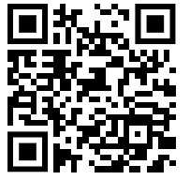
……………………………………………………………. (Print name)

……………………………………………………………..(Date)

Scan the QR code to complete a digital version of the form or click here:

