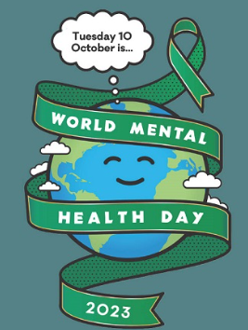

The theme was ‘Mental Health is a universal human right’.

Throughout the day each class developed a ‘Mental Health Toolkit’ which they will now be able to develop and use throughout the year. Classes explored how our brains respond to stress and some strategies that can help calm and soothe us.

EYFS
In Lemon and Lime classes, we have been exploring our emotions. We drew around one of us and the children thought about where we might see or feel our emotions. They came up with some great ideas and suggested we might get a tummy ache if we are worried or sad, or our heads might hurt or we might cry. They added some things to our drawings such as tears and a sad face. We spoke about starfish breathing, which is great to help us feel calmer. Ask your children to show you how to do it! Some children chose to draw around their hands and cut them out to remind them of starfish breathing.
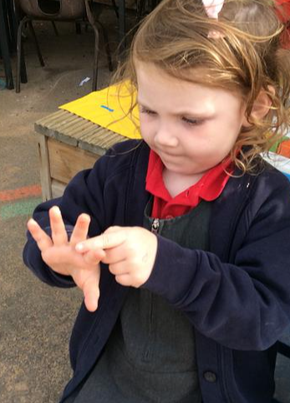
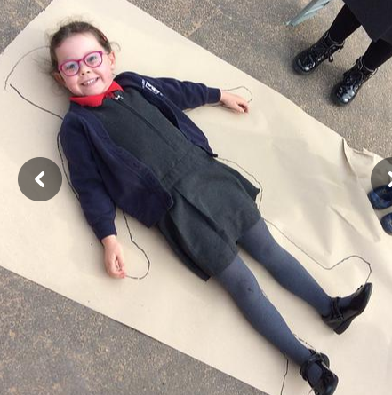

KS1
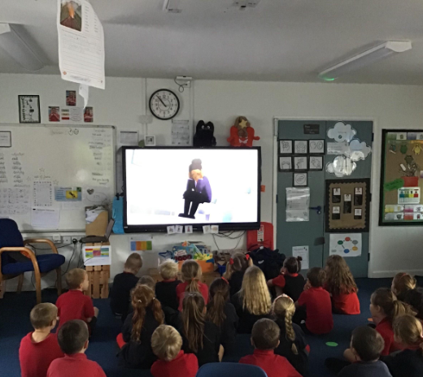
It is World Mental Health Day today. In KS1 we are exploring what that means, including how we can improve our own mental health in our day to day life. We are exploring mindfulness tactics today which I’m sure your children will speak about at home. Our motto always I’m Cherry/Pear/Apple Class - be kind

KS2
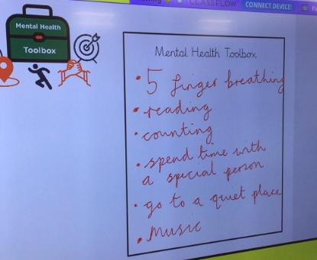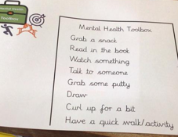
KS2 explored the range of emotions we might feel throughout the day. They worked collaboratively to develop a mental health toolbox in each class.

