Children’s Mental Health Week February 2024
My Voice Matters

During Mental Health Week, classes took part in some great activities including reading stories about using our voices, sharing positive comments to help people feel like they matter and taking the time to talk to people they don't normally spend time with.
It's was such a positive week here at St Mary's but of course mental health matters all the time. So, let's keep these conversations going and talk about our feelings!
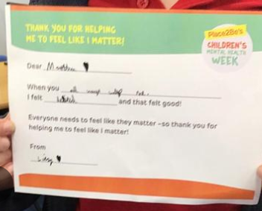
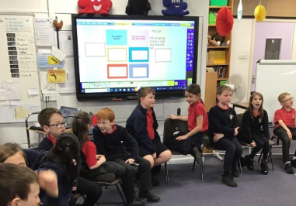

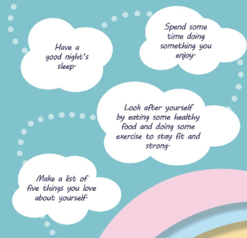
An important part of mental health is taking care of yourself. Here are some top tips for everyone!

Talking about feelings is so important! Here are some conversation starters to help get you and your children have those chats that can make such a difference.
