St Mary’s Policy for Play

- Commitment
At St Mary’s Primary School, we are committed to embedding our values of ‘Enjoy, Explore, Excel together; be amazing!’ within all aspects of school life - including play. We recognise that play is integral to a happy and healthy childhood and we are therefore committed to providing high quality play.

Our school undertakes to refer to this play policy in all decisions, which affect children's play. Our school is committed to providing the strategic and operational leadership needed to provide and maintain quality play provision for all of our children.

- Rationale

Children spend up to 20% (1.4 years) of their time in school at play. This is a significant portion of their school life and is an opportunity to continue their learning. Better play means that children enjoy school more, are happier to come to school and have an overall improved attitude towards school. This can benefit children’s general behaviour, increasing the time available within the school day for learning and engagement within the classroom.

Our school believes that all children need opportunities to play to enable them to explore, manipulate, experience and affect their environment. The school acknowledges the UN Convention on the Rights of the Child, especially Article 31, and fully supports the child’s right to play. We believe play provision should be welcoming and accessible to every child, irrespective of gender, sexual orientation, economic or social circumstances, ethnic or cultural background or origin, or individual abilities.

The OPAL programme rationale is that …”better, more active and creative playtimes can mean happier and healthier children, and having happier, healthier, more active children usually results in a more positive attitude to learning in school, with more effective classroom lessons, less staff time spent resolving unnecessary behavioural problems, fewer playtime accidents, happier staff and a healthier attitude to life”.

St Mary’s school values are central to the approach to play. Better play will allow children more opportunities to experience and live those values.

- Enjoy: Children have a right to play, to make their own choices about what, where and how they play, and who they play with so that they enjoy their play and experience the benefits it brings.
- Explore: Better play allows children the opportunity to explore their environment, develop their imagination and creativity, explore their own boundaries and take risks.
- Excel: Developing and improving play will provide wider benefits to children encouraging them to be creative, imaginative and create an environment in which they can excel as individuals.
- Be Amazing! – The benefits of play mean healthier and happier children who then are supported to ‘be amazing’ in all aspects of school. Better play creates new ways for children to be amazing.

- Definition and Value of Play
Play is defined as any freely chosen activity which a child finds satisfying and creative. Play England define play as ‘What children and young people do when they follow their own ideas and interests, in their own way, and for their own reasons.’ It may or may not involve equipment or other people. We believe play has many benefits which have been widely evidenced through research, including:

- Play is critical to children’s health and wellbeing, and essential for their physical, emotional, social, spiritual and intellectual development.
- Play enables children to explore the physical and social environment, different concepts and different ideas.
- Play enhances children’s self-esteem and their understanding of others through freely chosen social interactions, within peer groups, with individuals, and within groups of different ages, abilities, interests, genders, ethnicities and cultures.
- Play requires ongoing communication and negotiation skills, enabling children to develop a balance between their right to act freely and their responsibilities to others.
- Play enables children to experience a wide range of emotions and develop their ability to cope with these, including sadness and happiness, rejection and acceptance, frustration and achievement, boredom and fascination, fear and confidence.
- Play encourages self-confidence and the ability to make choices, problem solve and to be creative.
- Play maintains children’s openness to learning, develops their capabilities and allows them to push the boundaries of what they can achieve.

Play England suggest there is also evidence that outlines wider benefits of play for families and communities, including:
- Parents can feel more secure knowing that their children are happy, safe and enjoying themselves.
- Families benefit from healthier, happier children.
- It offers opportunities for social interaction within the wider community.

- Aims
In relation to play, our school aims to:

- ensure play settings provide a varied, challenging and stimulating environment.
- allow children to take risks and use a common-sense approach to the management of these risks and their benefits.
- provide opportunities for children to develop their relationships with each other.
- enable children to develop respect for their surroundings and each other.
- aid children’s physical, emotional, social, spiritual and intellectual development.
- provide a range of environments which will encourage children to explore and play imaginatively.
- provide a range of environments which will support children’s learning across the curriculum and learning about the world around them.
- promote independence and teamwork within children.
- build emotional and physical resilience.

- Rights
Our school recognises the UN Convention on the Rights of the Child which includes the right to play, recreation and leisure (Article 31) and the right of children to be listened to on matters important to them (Article 12). We acknowledge that we have a duty take these rights seriously and listen to children’s views on their play. At St Mary’s, our school values are central to what children can expect to experience throughout the whole of the school day, including play.

- Benefit and Risk
‘Play is great for children’s well-being and development. When planning and providing play opportunities, the goal is not to eliminate risk, but to weigh up the risks and benefits. No child will learn about risk if they are wrapped in cotton wool’
Managing Risk in Play Provision: An Implementation Guide (2012)

The school will use the Health and Safety Executive guidance document ‘Children’s Play and Leisure – Promoting a Balanced Approach’ (September 2012) as the principle value statement informing its approach to managing risk in play. In doing so, the school will adopt a risk-benefit approach as detailed in ‘Managing Risk in Play Provision’: An Implementation Guide. See Appendix 1

Risk-taking is an essential feature of play provision, and of all environments in which children legitimately spend time at play. Play provision aims to offer children the chance to encounter acceptable risks as part of a stimulating, challenging and managed play environment. In the words of the play sector publication ‘Best Play’, play provision should aim to ‘manage the balance between the need to offer risk and the need to keep children and young people safe from harm’.

‘Without opportunities to take acceptable levels of risk, children’s development is inhibited, undermining their capability to deal with the wider unsupervised world’. (Department for Education)

As facilitators of play, the school’s role is to help children learn to manage risk for themselves in an environment that is as safe as it needs to be, rather than as safe as it can be. The benefit to children of challenging play opportunities should be balanced with any potential risk when carrying out risk assessments. In addition to standard risk/benefit assessments the school will practice dynamic risk management with the children encouraging them to identify and manage risks in an environment where adults are present to support them.

- Supervision
The law requires that children in school have supervision but for primary school playtimes there are no stated ratios. During the school day there should be one or more adults present outdoors. The school recognizes OPAL’s three models of supervision: Direct, Remote and Ranging. Except for new children in reception, the school does not believe direct supervision is possible or beneficial. Supervision will take remote and ranging models, so that children can quickly find an adult, and adults can patrol large sites to gain an awareness of the kinds of play and levels of risk likely to be emerging. Supervision should also be guided by the values, rules and behaviour policy of the school.

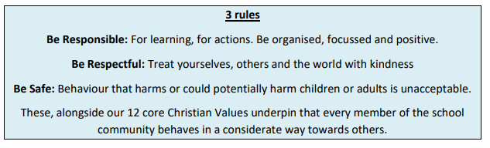

- The Adults' Role in Play
The school will help children maximize the benefits they can gain from play, by the provision of trained staff who are informed by and work in accordance with the Playwork Principles. Staff will use and refer to these principles when appropriate interventions are needed, and ultimately will strive for facilitating an environment which nurtures children’s self-directed play.

The playworker's core function is to create an environment which will stimulate children's play and maximise their opportunities for a wide range of play experiences. A skilled and experienced playworker is capable of enriching the child's play experience both in terms of the design and resources of the physical environment and in terms of the attitudes and culture fostered within the play setting. Playworkers are a channel of access to new materials and tools and they can act as a stimulus to children to explore and learn. They are also available to participate in the play if invited.

As a school, we are committed to working with children to develop play that they want and need in their school. The School Council will meet to discuss play provision, there will be scheduled play assemblies throughout the year and pupil voice will be gathered.

- Environment
We believe that a rich play setting should ensure that all children have access to stimulating environments that are free from unacceptable/unnecessary risks and thereby offer children the opportunity to explore for themselves through their freely chosen play.

We will strive to continually improve the quality and diversity of our school’s grounds to enhance play. We will use the document ‘Best Play’ – To guide us on what a quality play environment should contain.
http://www.playengland.org.uk/resource/best-play/

As a school, we will:
- Ensure the outdoor environment offers all children the opportunity to investigate, take risks, explore, be creative and use their imagination.
- Include the children in the development and planning for the play environment.
- Support children to respect their environment.

Appendix 1
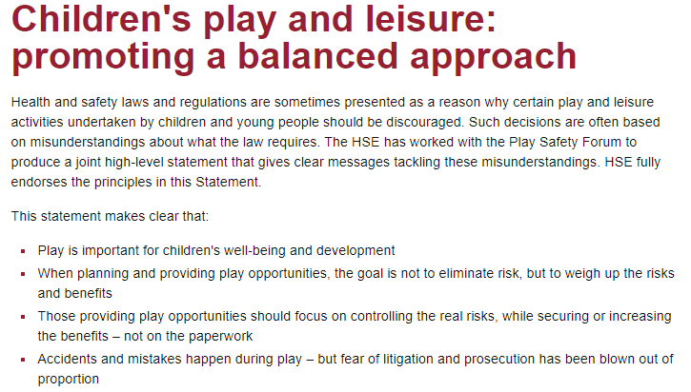

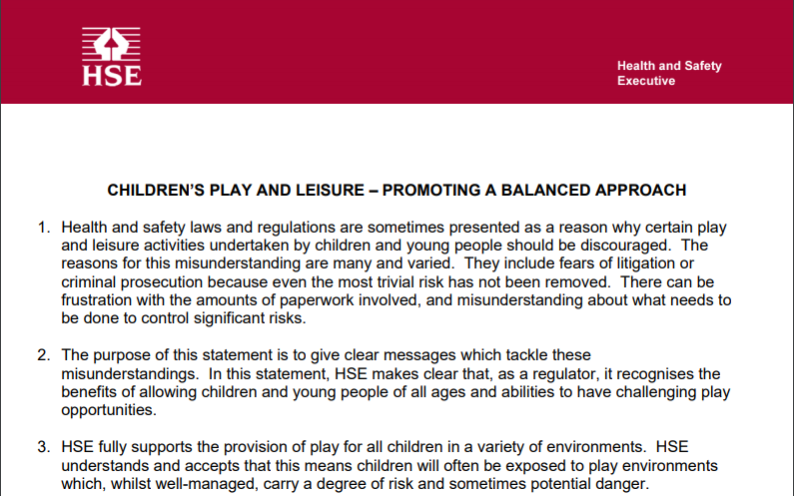
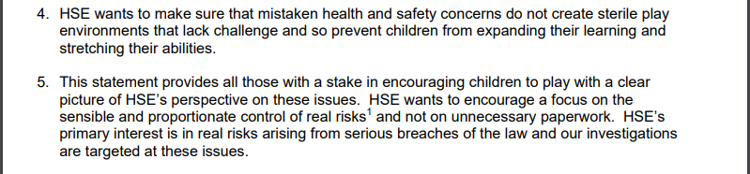

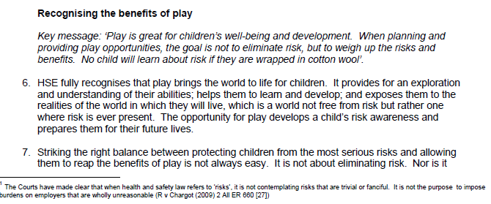

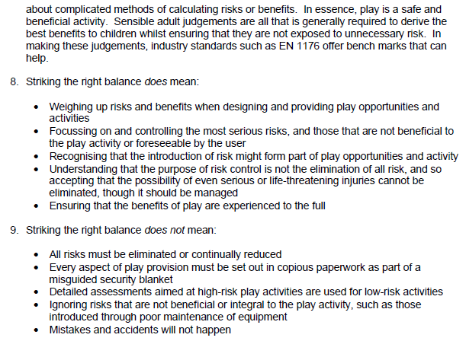

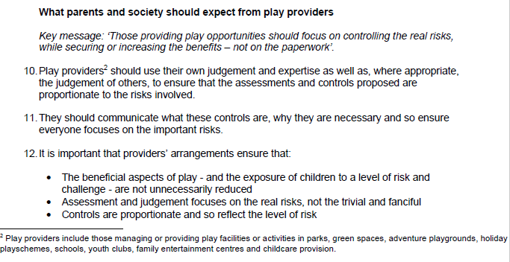

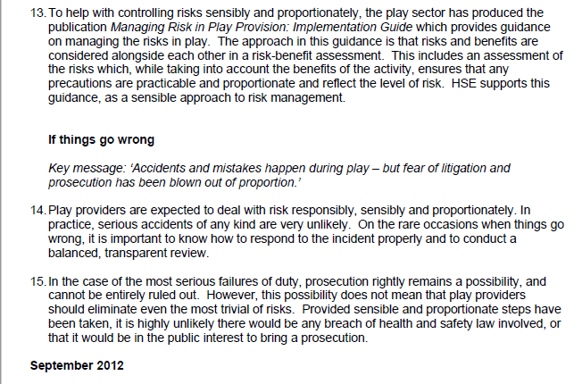

Managing Risk in Play: Implementation Guide can be accessed here:
https://playsafetyforum.files.wordpress.com/2015/03/managing-risk-in-play-provision.pdf

