Curriculum Subject Page for Website
Phonics and Early Reading
At St Mary’s we believe that promoting a love of reading is intrinsic to a child’s education, development and happiness. We work with all children to ensure that this begins with the youngest members of our school community and continues throughout their time in school. As soon as a child joins St Mary’s, they are introduced to a literacy rich environment that ensures that we:
- Foster a love of reading and sharing stories, poems and rhymes to develop vocabulary and comprehension through Drawing Club, Adventure Island and Poetry Basket.
- Develop children's Communication and Language skills to ensure they can listen, attend and understand language through Helicopter Stories and Babblejab.
- Ensure children are taught early phonics skills through our systematic, synthetic phonics programme Read Write Inc.
- Create opportunities for children to read and reread books that match the phonics stage taught.
- Provide opportunities within Child Initiated, Adult initiated and Adult directed activities for the children to apply and rehearse early phonics and reading skills in a range of contexts.
- Effectively use assessment to quickly identify the children that need additional support to keep up through 1:1 tutoring and spotlighting during teacher input.
- To offer challenge to the children who are applying and using phonics skills early on in their school journey to ensure we nurture and continue to move children forward to achieve.

Early reading and phonics skills are nurtured and developed across the continuous provision, giving children the opportunity to apply their skills in a range of play-based activities and meaningful contexts. We use Drawing Club, the Message Centre and Play Projects to ignite imaginations and the adults are highly skilled in working at the cusp of children’s learning, providing guidance, support and challenge to children as they practice and consolidate these early reading skills.
Alongside the continuous provision, the following sessions are planned to ensure children develop strong Communication & Language, Phonics, reading and writing skills, during their time across EYFS and Year 1.
- Children in Reception and Year 1 will complete a daily phonics session, following our synthetic and systematic phonics programme: Read Write Inc.
- Children in EYFS will enjoy a daily Drawing Club with a different book shared each week.
- Children in EYFS and Year 1 will enjoy an end of day story to develop and foster their love for reading. These books are often linked to our school value for the term or our connected curriculum.
- Weekly 1:1 reading will take place in Reception and in Year 1.
- Mystery Reader will take place weekly from Term 2.
- Our trained Reading Volunteers will work closely with the Reception classes to instil a love of reading in the children.
Our Phonic Program, Read, Write, Inc enables us to ensure children learn to read fluently and at speed so they can focus on developing their skills in comprehension, vocabulary and spelling. Through assessment and early intervention through tutoring we can ensure children in Year 1 are equipped to pass the Phonic Screening Test and that no child is left behind in their phonic learning journey. ‘Keep up not Catch Up’.

How we teach Phonics
At St Mary’s, Phonics is taught through the scheme Read, Write, Inc. Read Write Inc. was first created by Ruth Miskin in 2002. It is the UK’s leading synthetic phonics programme. Read Write Inc. is for children from EYFS to Year 4, and children with SEND in older year groups. Phonics is taught daily to all children in EYFS, Year 1 and those in Year 2 who have not passed the phonics screening in Year 1 or completed the Read, Write, Inc phonics programme.
RWI promotes good progress for all children and works at a pace right for the individual child.
The children in EYFS begin their phonics journey as soon as they start school full time, learning phonic sounds in daily phonic sessions and how to blend these sounds together to both read and write new words. Once the children can blend they begin reading Red Ditty Books and as their fluency increases, they move fluidly through the scheme finishing with grey book. All reading books progress cumulatively, matched to the sound’s children are learning and already know. The link below will support you in reading with your child at home.
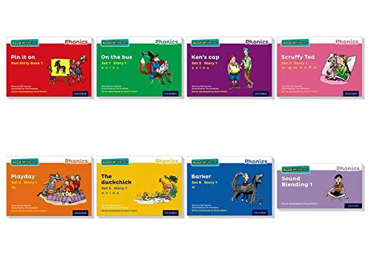
Read, Write Inc Reading Scheme Books
Listening to your child read:
https://schools.ruthmiskin.com/training/view/lvJZpiBm/igypIT84

The teaching of phonics is of high priority. During each daily RWinc session, the children are taught or revise a phonic sound, learn to segment and blend story green words with the support of Fred who only speaks using Fred Talk, read on-sight story red words and work on their reading fluency with a reading partner, applying phonics to read decodable books. The books will come home after being read in school with their reading partner for the children to share and continue to practise their reading and fluency at home.
Each classroom has a speed sound chart displayed and used during and around explicit phonic sessions, in EYFS and KS1 table top phonic mat resources are always available as well as individual phonic cards in EYFS.
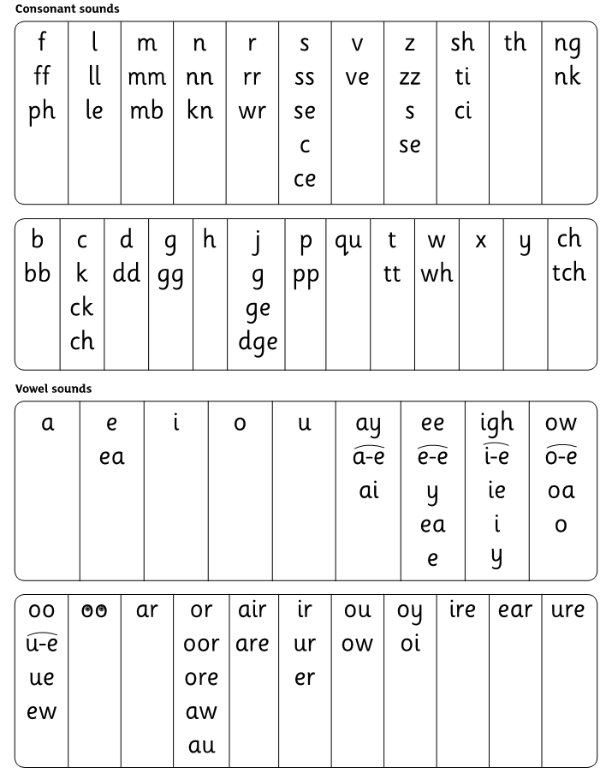 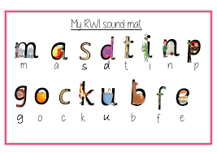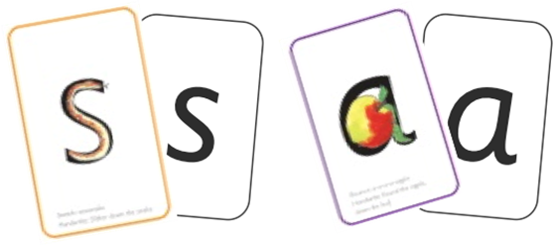Speed Sound Chart Table Top Phonic Mat Phonic Cards

How Phonics is assessed at St Mary’s
Children are assessed each term using the RWi assessment. The assessment ensures children are making progress with their fluency and from this they can be moved into the phonic group most suited to them. Meanwhile, phonic teachers are assessing children’s phonic recall, segmenting and blending and fluency during each session and children move fluidly between the groups accordingly between assessment points. We continually ensure the children are making progress and where necessary we begin daily tutoring as we believe children should keep up not catch up.

How to support your child:
In the EYFS, parents are sent a weekly email to inform them of the learning content for the following week which includes the Drawing Club book for the week and a copy of the poem we will be learning. Links to Read Write Inc sound videos and other ideas and suggestions to support and consolidate their child’s learning are offered.

Once your child begins the RWi Phonic Scheme, they will bring home a paper copy of the sound they have been taught that day for them to revise and practise letter formation with you, a video link to the sound taught that day will be available on ClassDojo – we highly recommend that these are watched with your child to reinforce and embed sounds being taught along with correct pronunciation. As they begin to blend sounds they have been taught to read and write new words they will bring home a Sound Blending Book to continue to practise sound recognition and blending at home, of which there are 10.
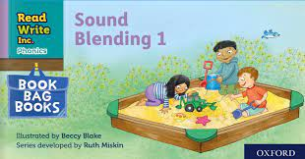
Supporting your child with reading using the Sound Blending Book

Home Reading Books
As well as their phonic group book, the children will bring home a RWInc Book Bag Book matched to their current level.
The children will have the opportunity to visit our school library once a week. They will listen to a story and choose a book to bring home. This book is not decodable and does not match where the children are in the RWI programme. Therefore, this is a book which an adult should read to the child for enjoyment and pleasure.
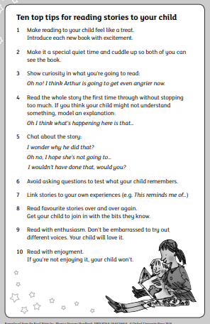
Top ten tips for reading stories to your child:
https://schools.ruthmiskin.com/training/view/35yofCWa/EQbKvzRY

