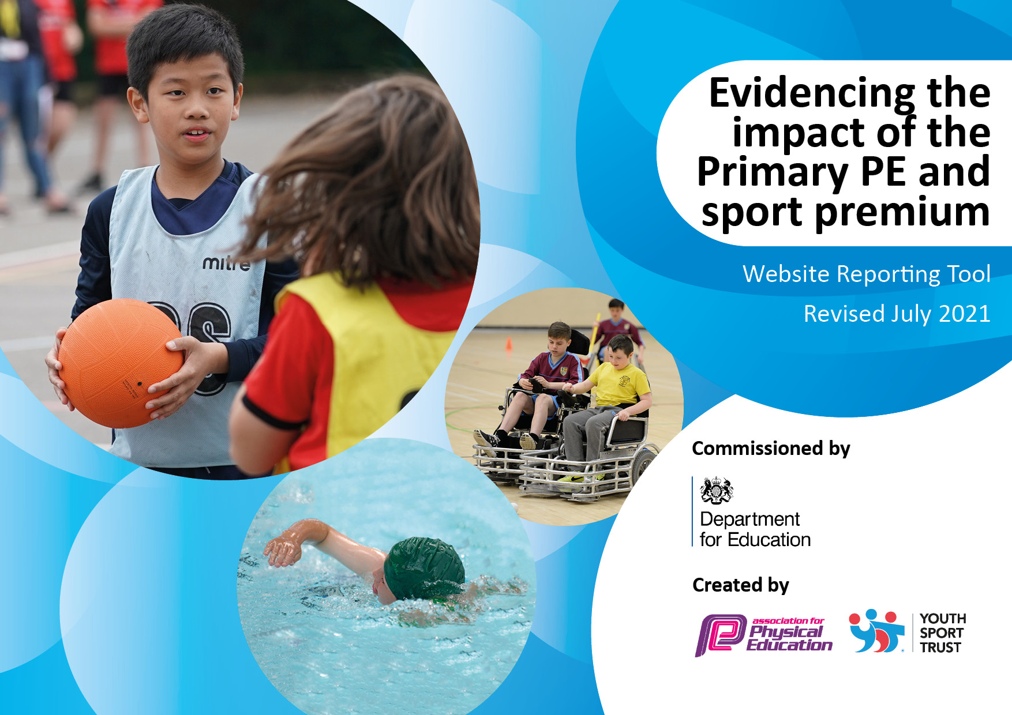
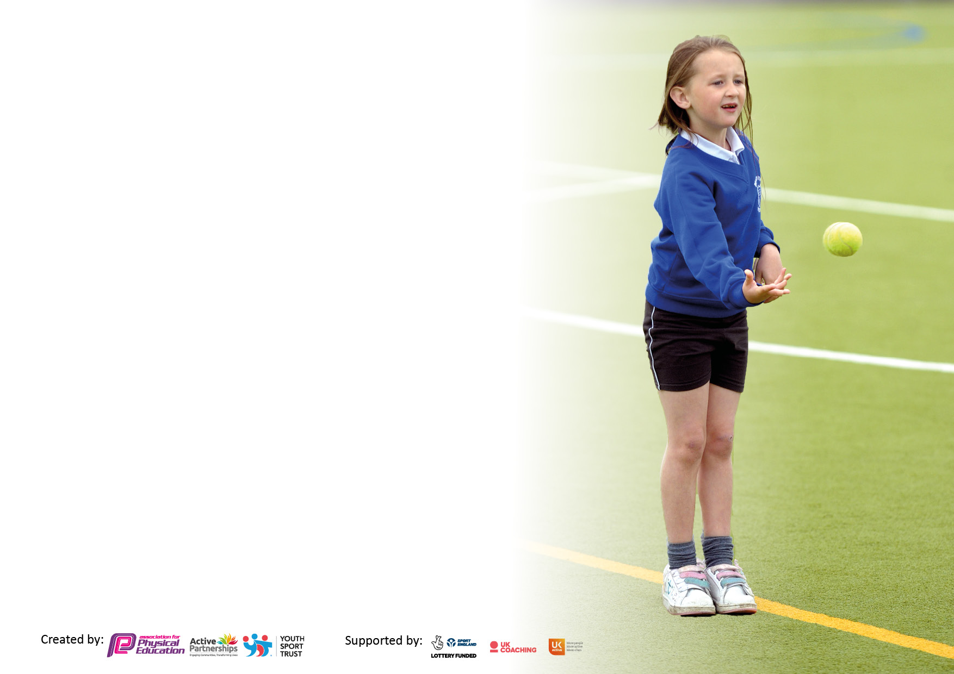

It is important that your grant is used effectively and based on school need. The Education Inspection Framework makes clear there will be a focus on ‘whether leaders and those responsible for governors all understand their respective roles and perform these in a way that enhances the effectiveness of the school’.

Under the Quality of Education Ofsted inspectors consider:
Intent - Curriculum design, coverage and appropriateness
Implementation - Curriculum delivery, Teaching (pedagogy) and Assessment
Impact - Attainment and progress

To assist schools with common transferable language this template has been developed to utilise the same three headings which should make your plans easily transferable between working documents.

Schools must use the funding to make additional and sustainable improvements to the quality of Physical Education, School Sport and Physical Activity (PESSPA) they offer. This means that you should use the Primary PE and sport premium to:

- Develop or add to the PESSPA activities that your school already offer
- Build capacity and capability within the school to ensure that improvements made now will benefit pupils joining the school in future years
- The Primary PE and sport premium should not be used to fund capital spend projects; the school’s budget should fund these.

Pleasevisitgov.ukfortherevisedDfEguidanceincludingthe5keyindicatorsacrosswhichschoolsshoulddemonstrate animprovement.Thisdocumentwillhelpyoutoreviewyourprovisionandtoreportyourspend.DfEencouragesschools to use this template as an effective way of meeting the reporting requirements of the Primary PE and sport premium.

We recommend you start by reflecting on the impact of current provision and reviewing the previous spend.

Schools are required to publish details of how they spend this funding, including any under-spend from 2019/2020, as well as on the impact it has on pupils’ PE and sport participation and attainment. All funding must be spent by 31st July 2022.

We recommend regularly updating the table and publishing it on your website throughout the year. This evidences your ongoing self-evaluation of how you are using the funding to secure maximum, sustainable impact. Final copy must be posted on your website by the end of the academic year and no later than the 31st July 2021. To see an example of how to complete the table please click HERE.

Details with regard to funding
Please complete the table below.

Total amount carried over from 2019/20 | £0
Total amount allocated for 2020/21 | £18,850
How much (if any) do you intend to carry over from this total fund into 2021/22? | £0
Total amount allocated for 2021/22 | £18,850.17
Total amount of funding for 2021/22. To be spent and reported on by 31st July 2022. | £ 18,850.17
Swimming Data
Please report on your Swimming Data below.

Meeting national curriculum requirements for swimming and water safety.

N.B. Complete this section to your best ability. For example you might have practised safe self-rescue techniques on dry land which you can then transfer to the pool when school swimming restarts.
Due to exceptional circumstances priority should be given to ensuring that pupils can perform safe self rescue even if they do not fully meet the first two requirements of the NC programme of study
What percentage of your current Year 6 cohort swim competently, confidently and proficiently over a distance of at least 25 metres?  N.B. Even though your pupils may swim in another year please report on their attainment on leaving primary school at the end of the summer term 2020.  Please see note above | 59%
What percentage of your current Year 6 cohort use a range of strokes effectively [for example, front crawl, backstroke and breaststroke]?  Please see note above | 59%
What percentage of your current Year 6 cohort perform safe self-rescue in different water-based situations? | 59%
Schools can choose to use the Primary PE and sport premium to provide additional provision for swimming but this must be for activity over and above the national curriculum requirements. Have you used it in this way? | Yes for 3 year 6 pupils

Action Plan and Budget Tracking
Capture your intended annual spend against the 5 key indicators. Clarify the success criteria and evidence of impact that you intend to measure to evaluate for pupils today and for the future.

Academic Year: 2021/22 | Total fund allocated: £18,850.17 | Date Updated:31/7/22
Key indicator 1: The engagement of all pupils in regular physical activity – Chief Medical Officers guidelines recommend that primary school pupils undertake at least 30 minutes of physical activity a day in school |  |  |  | Percentage of total allocation:
 |  |  |  | %
Intent | Implementation |  | Impact
Your school focus should be clear what you want the pupils to know and be able to do and about  what they need to learn and to  consolidate through practice: | Make sure your actions to achieve are linked to your intentions: | Funding allocated: | Evidence of impact: what do pupils now know and what can they now do? What has changed?: | Sustainability and suggested next steps:
-the development of lunchtime opportunities and get involved in more activities  - training of sports leaders offering a bigger range of physical activities across the school | -additional member of staff to undertake activities with the pupils at lunchtime  -purchase a range of activities that the pupils will want and involve as many as possible  -Y5 attend playground leaders training as part of South Glos PE association  -create and implement a timetable of physical activities that will be available to the pupils as part of OPAL project  - Sports clubs on two lunch times coordinated through Bristol Sport. Tuesday: focus on reluctant participants  Wednesday: club for anyone | £0  £200  £50  £500  £5500 | -Increase in the range of activities offered to our pupils and therefore being more active in the morning  -Increased number of sports leaders across KS2  -Termly intra competitions  -Increase number of pupils taking part in physical activity at lunchtimes | -Link the range of activities offered with the introduction of the daily mile.  -Attend future leadership training to upskill more pupils to carryout playground leading  -Further develop the range of intra competitions available to the pupils  -Link all lunchtime clubs, playpod and sporting opportunities activities together.
Key indicator 2: The profile of PESSPA being raised across the school as a tool for whole school improvement |  |  |  | Percentage of total allocation:
 |  |  |  | %
Intent | Implementation |  | Impact
Your school focus should be clear what you want the pupils to know and be able to do and about  what they need to learn and to  consolidate through practice: | Make sure your actions to achieve are linked to your intentions: | Funding allocated: | Evidence of impact: what do pupils now know and what can they now do? What has changed?: | Sustainability and suggested next steps:
-PE notice board in the main corridor to promote the profile of PE and Sport across the school  -Weekly posts on DOJO to promote the profile of PE and Sport across the school  -Celebration assembly every Friday to share all the PE and sporting achievements in and outside school  -Regular Inter competitions  -More inclusive sport made available to all pupils | -Increase the range of display board space available to promote PE and sport.  -Photographs, results, certificates and comments displayed on the PE and sport board.  -Use celebration assembly as a time to share certificates and reports for all competitions taken part in that week  -Increase the range and number of events that take place outside of school and celebrate.  -Increase the number of sporting activities that are available to all our pupils  Attended as part of South Glos PE association. Some focussed on reluctant participants. | £0  £50  £0  £825  £0  £50 | -PE and sports noticeboard full of activities our pupils have taken part in increasing the keenness to be all the board.  -All members of our school community are aware of all the amounts of events attended. Pupils like the effects the reports and photos have on their self esteem  -Pupils have an increased participation in celebration assembly with an increased focus on sport and PE  -Increased range of new sporting activities available for all pupils.  -Increased number of pupils taking part in competitive sport.  -Increased range of sporting activities available to all our pupils. | Create sports council next year for them to maintain the board  Create a termly newsletter and move this to include school twitter posts. Add to school newsletter.  -Make sure all sporting events and competitions have a pupil report for the newsletter.  SLT has seen the benefits of the raised profile in PE and the increased uptake in competitive sport.  Develop the range of intra competitions available to the pupils next year.  Look out for new sports next year and take part in further inclusive sport competitions

Key indicator 3: Increased confidence, knowledge and skills of all staff in teaching PE and sport |  |  |  | Percentage of total allocation:
 |  |  |  | %
Intent | Implementation |  | Impact
Your school focus should be clear | Make sure your actions to | Funding | Evidence of impact: what do | Sustainability and suggested
what you want the pupils to know | achieve are linked to your | allocated: | pupils now know and what | next steps:
and be able to do and about | intentions: |  | can they now do? What has
what they need to learn and to |  |  | changed?:
consolidate through practice:
-Increase the range of sports being offered across the school alongside increasing the range of sports our staff can teach | -Increase the use of Bristol Sport to teach PE across the school, offering specialist coaches and a greater range of sports  -Timetable sports coaching to all classes in year 1-6. Staff to team teach and observe where possible. Using ideas and lesson plans offered in future lessons. | £5500 | -Increased range of sports on offer to our pupils with handball, badminton now added.  -Increased confidence and better subject knowledge of a range of sports being taught in our school | -Increase the range of sports being offered across the school  -Extend the model into next year
Key indicator 4: Broader experience of a range of sports and activities offered to all pupils |  |  |  | Percentage of total allocation:
Intent | Implementation |  | Impact
Your school focus should be clear | Make sure your actions to | Funding | Evidence of impact: what do | Sustainability and suggested
what you want the pupils to know | achieve are linked to your | allocated: | pupils now know and what | next steps:
and be able to do and about | intentions: |  | can they now do? What has
what they need to learn and to |  |  | changed?:
consolidate through practice:
-Continue to offer a bigger range of sports and activities to our pupils  - Purchase of new PE equipment to replace broken/tired  - Increase pupils engagement in swimming lessons | -Take up the full range of sports partnerships level 2 and 3 competitions.  -Getting involved in any new sport opportunities offered to the school.  - To expand the participation of new sports such as badminton and Jail break  - Y6 catch up  - Y3 all | £50  £2,000  £1999.50 | -Continued increase in the number of pupils taking part in competitive sport this year.  -Increased number of sports offered and more opportunities for different groups of pupils.  -Increased number of pupils taking part in sports club outside of school  -Increased number of sports taken part competitions.  - increase in pupil’s enjoyment of new and current sports | -Review our PE overview for next year and put in new sports and link to our sports partnership competitions.

Key indicator 5: Increased participation in competitive sport |  |  |  | Percentage of total allocation:
 |  |  |  | %
Intent | Implementation |  | Impact
Your school focus should be clear | Make sure your actions to | Funding | Evidence of impact: what do | Sustainability and suggested
what you want the pupils to know | achieve are linked to your | allocated: | pupils now know and what | next steps:
and be able to do and about | intentions: |  | can they now do? What has
what they need to learn and to |  |  | changed?:
consolidate through practice:
To introduce more competitive sports offered through South Glos PE association, Bristol sport and YA SGO | -Increase the amount of intra competitions around school through our house system/trophy.  -Increase the number of competitions we enter at level 2 and 3 through our sports partnership and PE association | £3000 | -More pupils have experienced different activities with a competitive element  -More teams have achieved going through to the level 3 completion’s eg Dodgeball, Jailbreak , Athletics , netball, football | -Extend our intra competitions across the whole school.  -Renew our South glos PE association offering an extensive range of competitive sport.

Signed off by
Head Teacher: | Bethan Scriven
Date: | 11/7/22
Subject Leader: | Gabby Stell
Date: | 11/7/22
Governor:
Date: | 11/7/22

