CALCULATION POLICY
Addition
Year group | Objective | Concrete | Pictorial | Abstract
EYFS | Have a deep understanding of number to 10, including the composition of each number. | 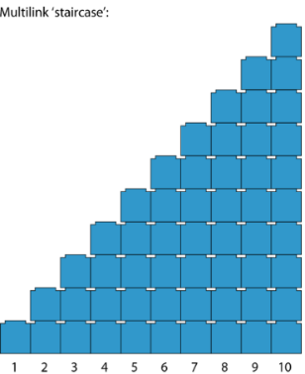  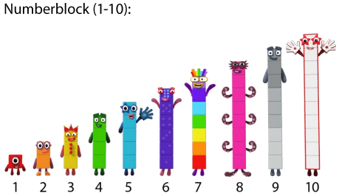  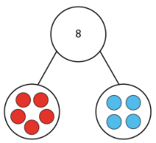    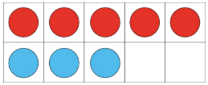  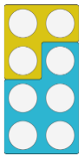 | 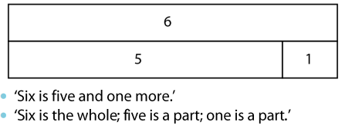  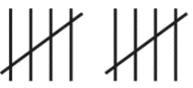  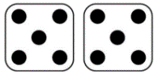  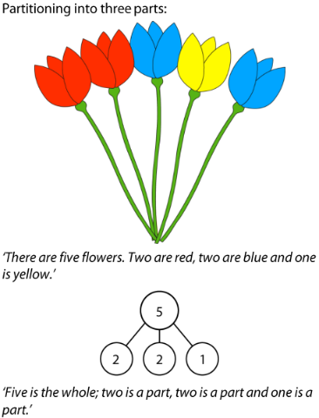  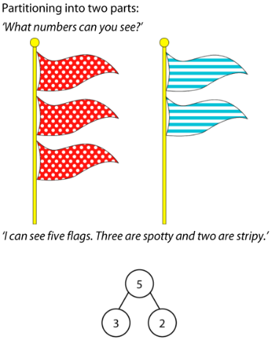  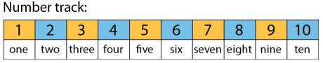 | 5 + 1 = 6  Vary the position of the equals symbol:  6 = 5 + 1
EYFS | Adding more | The children use real life objects to see that the quantity of a group can be changed by adding more. The first, then, now structure can be used to create mathematical stories in meaningful contexts. Encourage the children to represent the number stories using 10 frames, number tracks and their fingers.  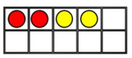 | 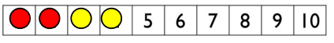  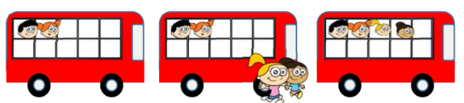 | As above
Year 1 | Add two 1-digit numbers to 10.  Add 1 and 2 digit numbers to 20. | 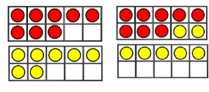  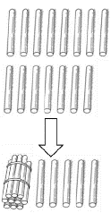  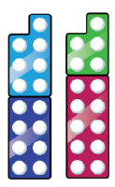 | 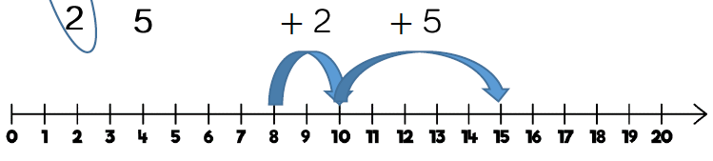  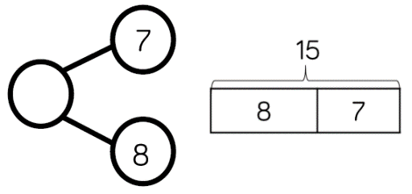 | 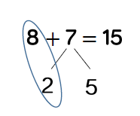
Year 2 | Add two 2-digit numbers to 100. | 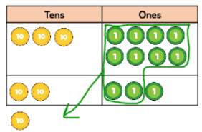  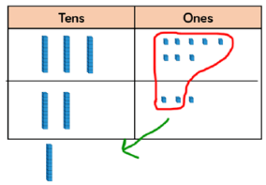  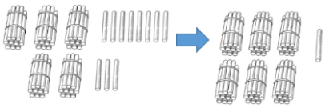  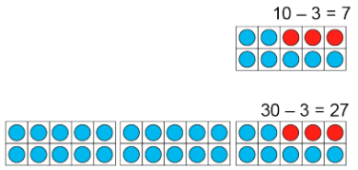 | Pupils can begin to think about the two quantities arranged in columns under place-value headings of tens and ones. They can use counters or draw tens 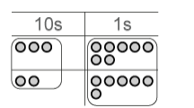and ones for support:  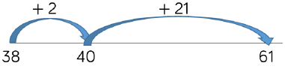  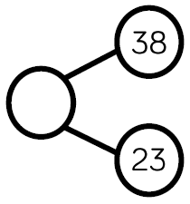  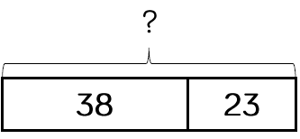 | 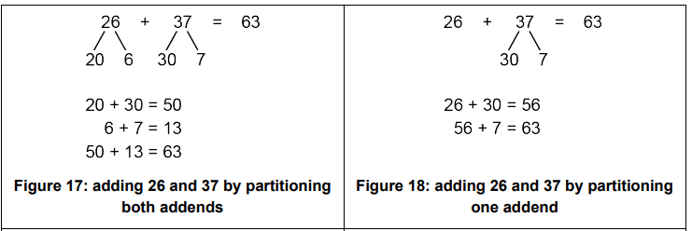  To avoid overload of working memory, pupils should learn how to record the steps using informal written notation or equation sequences, as shown below.  Figure 18 is the most efficient.
Year 3 | Add numbers with up to 3-digits. | 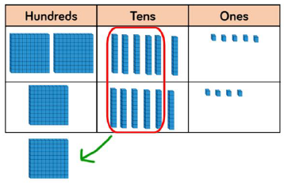  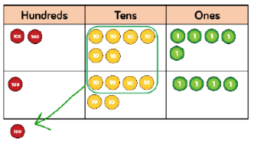 | 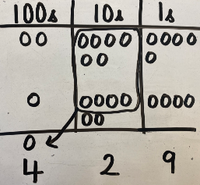  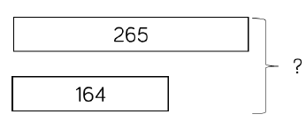  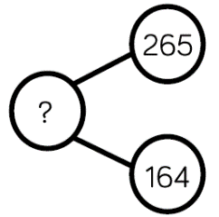 | 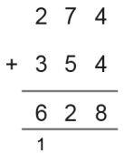  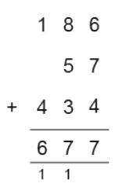  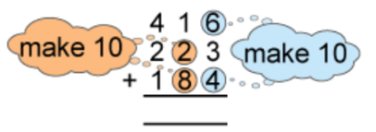  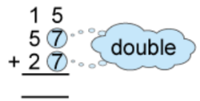
Year 4 | Add numbers with up to 4-digits. | 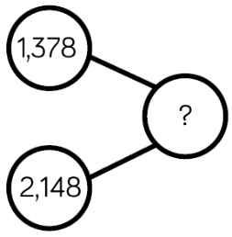  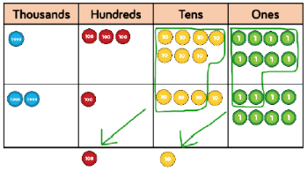  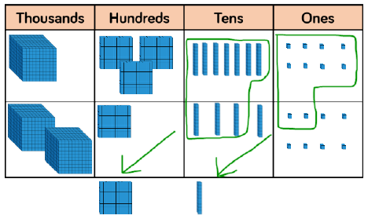 | 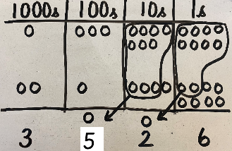  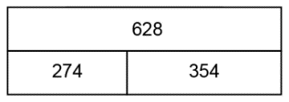  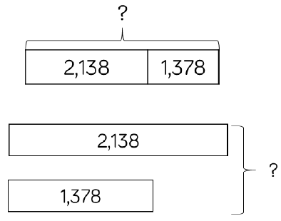 | 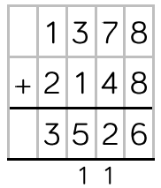
Year 5/6 | Add numbers with more than 4-digits. | 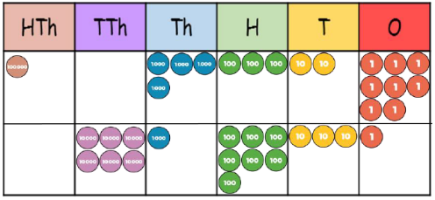 | 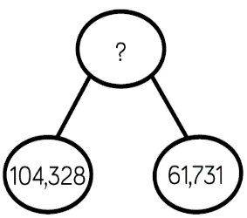  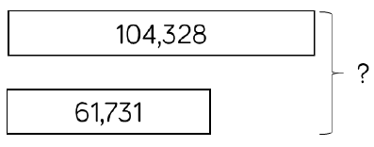  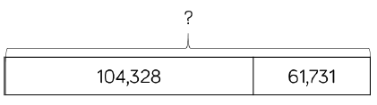 | 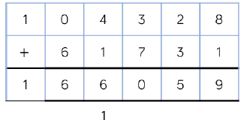

Subtraction
Year group | Objective | Concrete | Pictorial | Abstract
EYFS | Taking away | The children use real objects to see that the quantity of a group can be changed by taking items away. The first, then, now structure can be used to create mathematical stories in meaningful contexts.  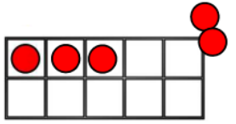 |   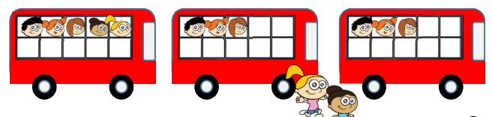 | 5 – 2 = 3  Vary the position of the equals symbol:  3 = 5 - 2
Year 1 | Subtract 1- digit numbers within 10  Subtract 1 and 2-digit numbers to 20 |     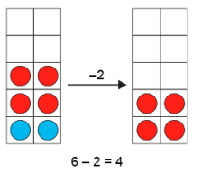  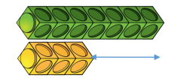  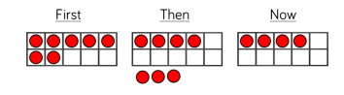  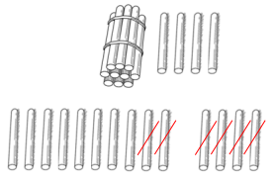  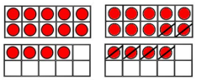 | 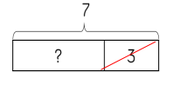  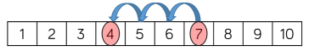  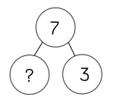  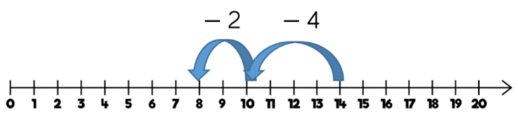  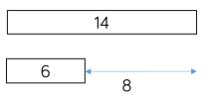 | 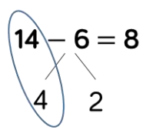
Year 2 | Subtract 1 and 2-digit numbers to 100 | 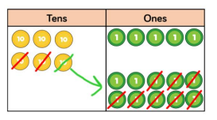  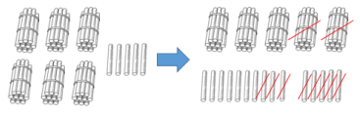  As numbers become larger, straws become less efficient.  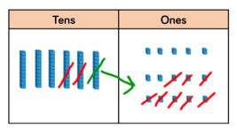 | 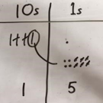  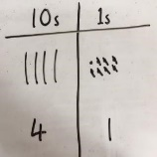  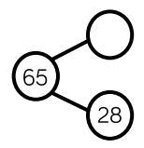  Pupils can begin to think about the two quantities arranged in columns under place-value headings of tens and ones. They can use counters or draw tens and ones for support.  1  1  5  10  10  10  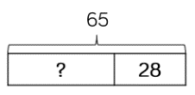  28 38 48 58 59 60 65 | To avoid overload of working memory, pupils should learn how to record the steps using informal written notation or equation sequences, as shown below.  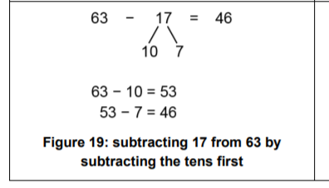
Year 3 | Subtract numbers with up to 3-digits | 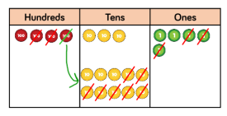  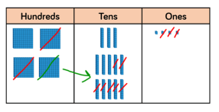 | 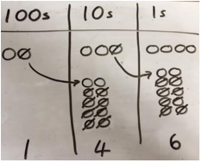  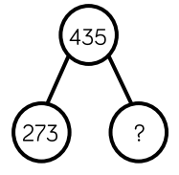  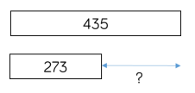  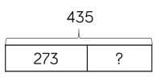 | 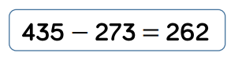  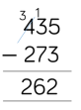
Year 4 | Subtract numbers with up to 4-digits | 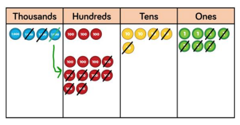  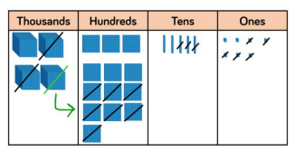 | 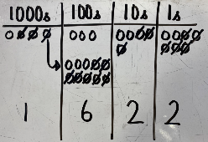  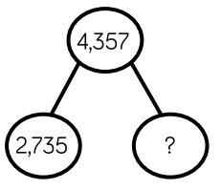  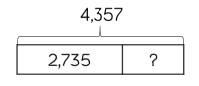  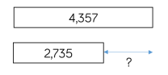 | 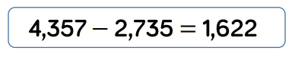  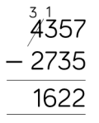
Year 5 | Subtract with up to 3 decimal places | 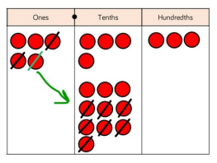  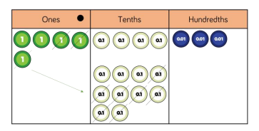 | 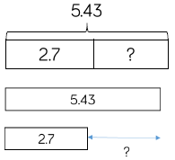  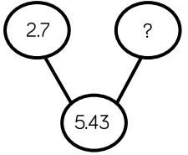 | 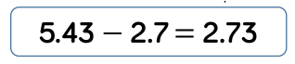  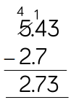
Year 5/6 | Subtract numbers with more than 4 – digits. | 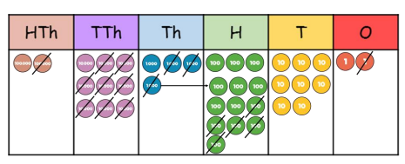 | 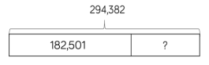  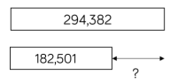 | 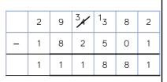  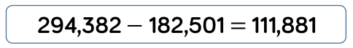

Multiplication
Year group | Objective | Concrete | Pictorial | Abstract
EYFS | Explore and represent patterns within numbers up to 10, including evens and odds, double facts and how quantities can be distributed equally.  Same objective within ‘Division’. | 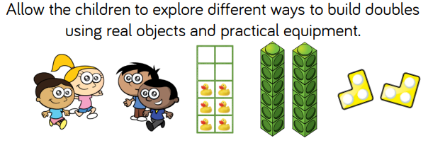  Sharing:  Grouping:  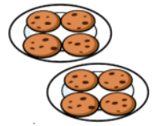  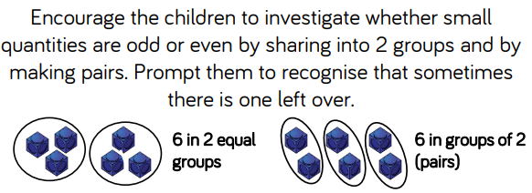   | 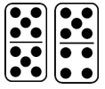  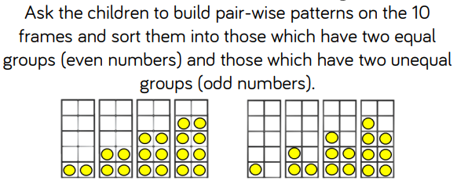 | Children will verbalise as they explore. For example -  Double 2 is 4.  Twice as many as 2 is 4.  Match a quantity using digit cards.  During snack time or group activities, encourage them to check that the items are shared equally and that everyone has the same. The children should also be given opportunities to recognise and make equal groups.  The children will notice that sometimes there are items left over when they share or group. Encourage them to come up with their own suggestions for how to resolve this.
Year 1/2 | 1-step multiplication problems linked to 2s, 5s and 10s. | 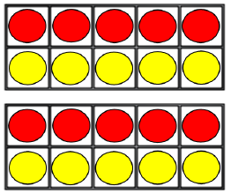  Children represent multiplication as repeated addition in many different ways using grouping.  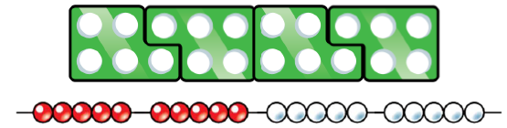 | 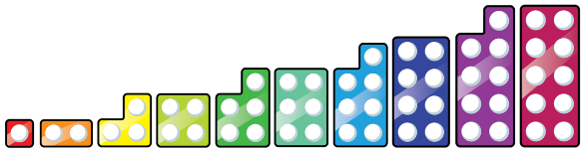  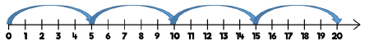  In Year 1, children use concrete and pictorial representations to solve problems until progressing onto the 10 times table.  Grouping:    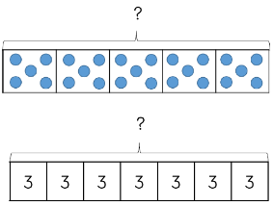  Arrays:  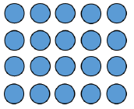 | In Year 2, children are introduced to the multiplication symbol.  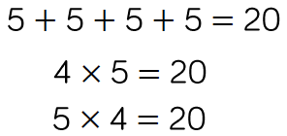
Year 3 | Multiply 2-digit numbers by 1-digit numbers | 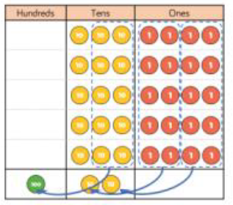  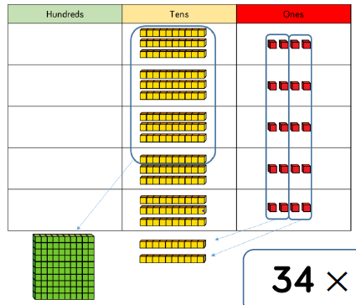 | 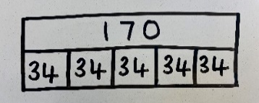 | 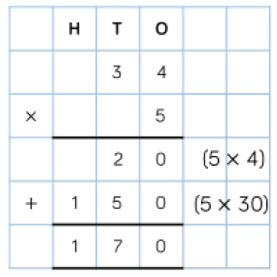  Teachers may decide to first look at the expanded column method before moving on to the short multiplication method.
Year 4 | Multiply 3-digit numbers by 1-digit numbers | 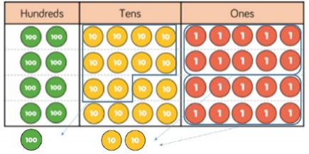  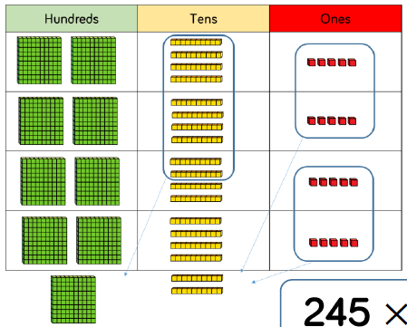 | 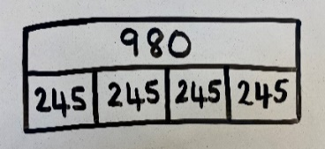  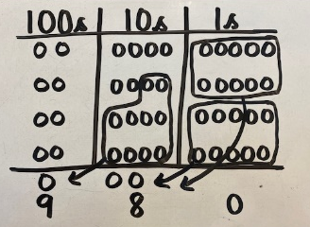 | 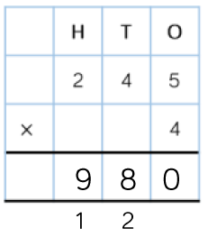  Revisit prior learning with the expanded column method. When moving to 3-digit by 1-digit multiplication, encourage children to move towards short, formal method.
Year 5 | Multiply 4-digit numbers by 1-digit numbers  Multiply 2-digit numbers by 2-digit numbers  Multiply 3-digit numbers by 2-digit numbers | 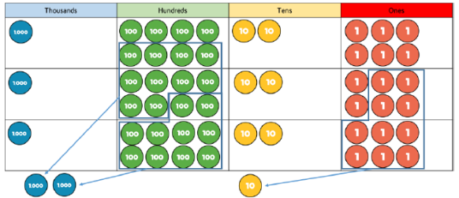  When multiplying 4-digit numbers, place value counters are the best manipulative to use. If children are multiplying larger numbers and struggling with their times tables, encourage the use of multiplication grids so children can focus on the use of the written method.  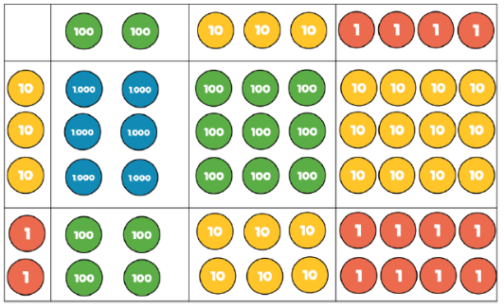  Multiply 2-digit numbers by 2-digit numbers and multiply 3-digit numbers by 2-digit numbers: | 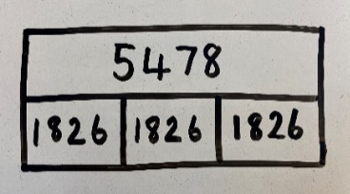  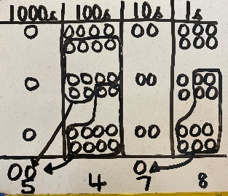 | 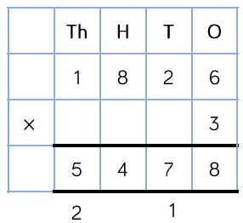  Multiply 4-digit numbers by 1-digit numbers:  Multiply 2-digit numbers by 2-digit numbers and multiply 3-digit numbers by 2-digit numbers:  Initially begin with the grid method (linking to prior learning with place value charts) prior to moving on to the formal written multiplication method.  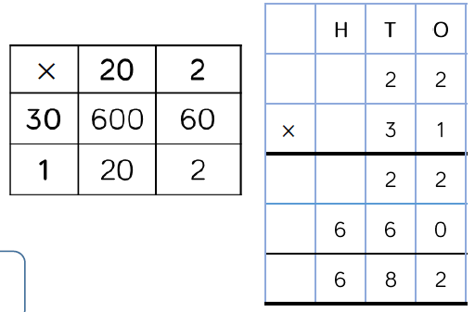
Year 5/6 | Multiply 4-digit numbers by 2-digit numbers |  |  | 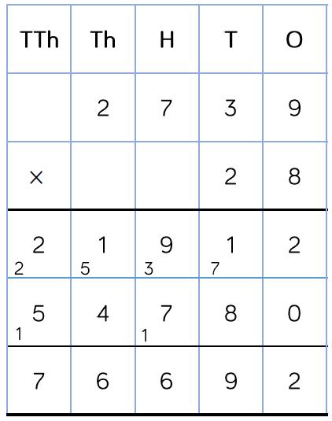

Division
Year group | Objective | Concrete | Pictorial | Abstract
EYFS | Explore and represent patterns within numbers up to 10, including evens and odds, double facts and how quantities can be distributed equally.  Same objective within ‘Multiplication’. | 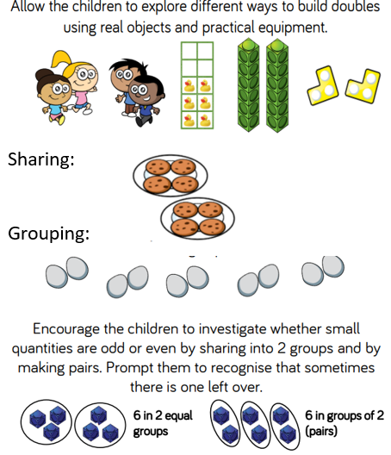 | 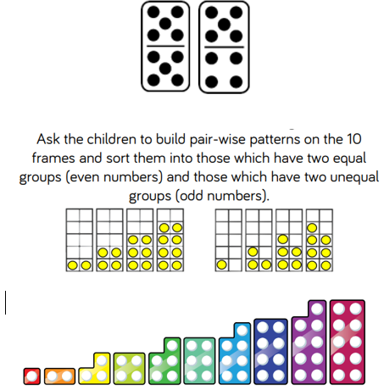 | Children will verbalise as they explore. For example -  Double 2 is 4.  Twice as many as 2 is 4.  Match a quantity using digit cards.  During snack time or group activities, encourage them to check that the items are shared equally and that everyone has the same. The children should also be given opportunities to recognise and make equal groups.  The children will notice that sometimes there are items left over when they share or group. Encourage them to come up with their own suggestions for how to resolve this.
Year 1/2 | Solve 1-step problems using division (sharing) | Children solve problems by sharing amounts into equal groups.  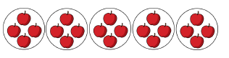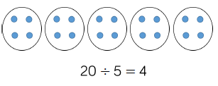 | 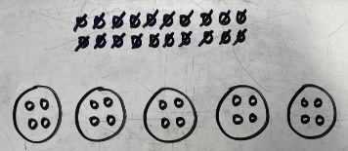  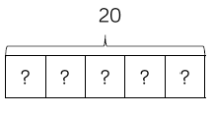  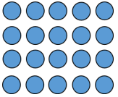  Arrays: | In Year 1, children use concrete and pictorial representations to solve problems. They are not expected to record division formally.  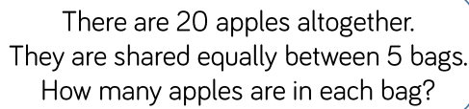  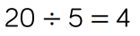  In Year 2, children are introduced to the division symbol.
Year 1/2 | Solve 1-step problems using division (grouping) | 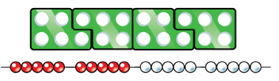  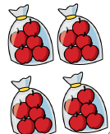  Children solve problems by grouping and counting the number of groups. They can use concrete representations in fixed groups. | 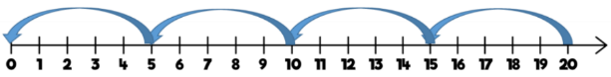  Grouping encourages children to count in multiples and links to repeated subtraction on a number line.  Arrays: | 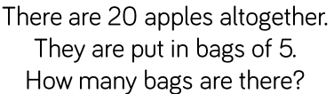
Year 1/2 | Divide 2-digits by 1-digit (sharing with no exchange) | When dividing larger numbers, children can use manipulatives that allow them to partition into tens and ones.  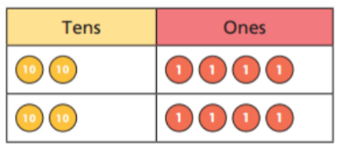  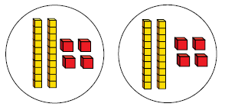  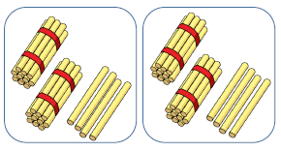 | 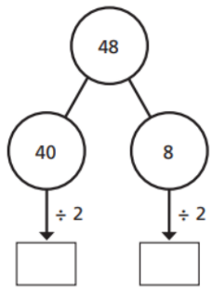 | 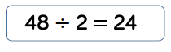
Year 3/4 | Divide 2-digits by 1-digit (sharing with exchange) | Children can use Base 10 (dienes) and place value counters to exchange one ten for ten ones. Children should start with the concrete resources outside the place value grid before sharing the tens and ones equally between the rows.  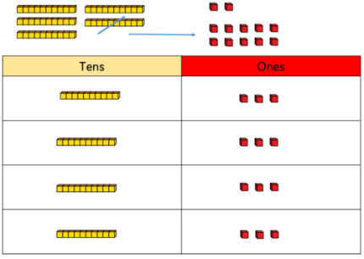  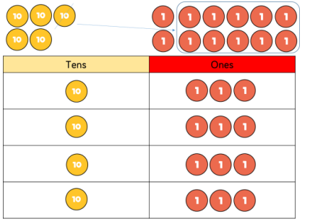 | 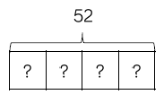  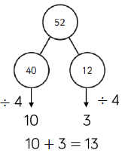  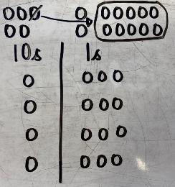 | 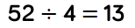
Year 3/4 | Divide 2-digits by 1-digit (sharing with remainders) | Starting with the concrete resources outside the place value grid will highlight remainders, as they will be left outside the grid once the equal groups have been made.  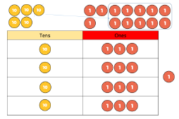  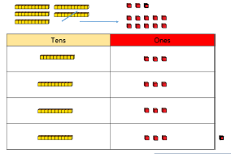 | 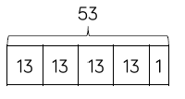  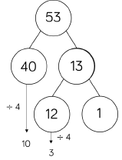 | 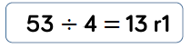  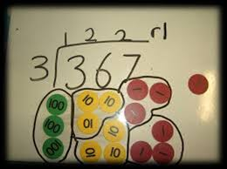
Year 4/5 | Divide 2-digits by 1- digit (grouping) | 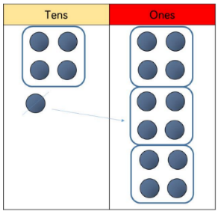  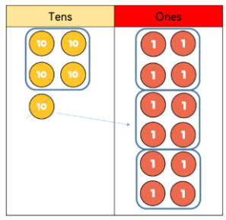  When using the short division method, children use grouping. Starting with the larger place value, they group by the divisor. Remainders can also be seen as they are left ungrouped. | 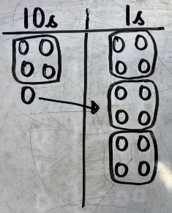
Year 4 | Divide 3-digits by 1-digit  (sharing) | 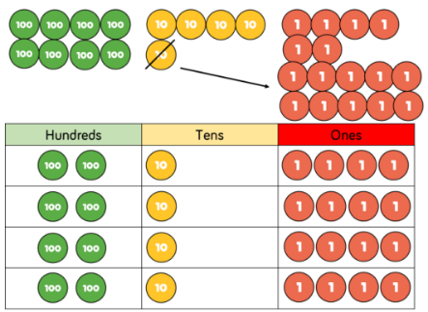  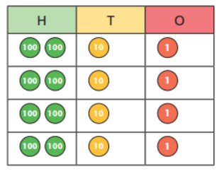 | 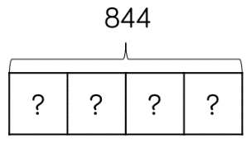  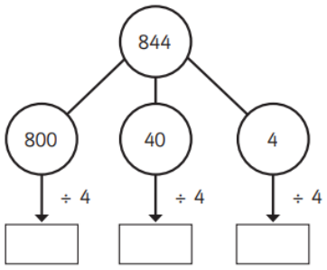 | 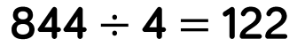
Year 5 | Divide 3-digits by 1-digit (grouping) | 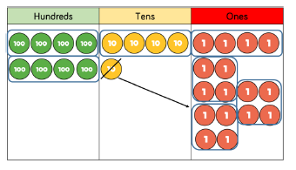  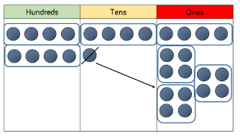 | 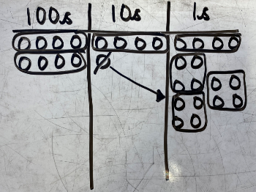 | 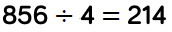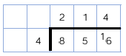
Year 5 | Divide 4-digits by 1-digit (grouping) | 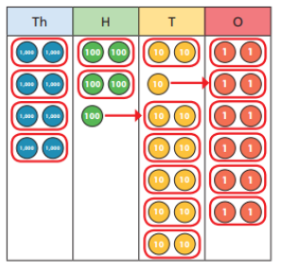 | Children can also draw their own counters and group them through a more pictorial method.  Children should be encouraged to move away from concrete and pictorial when dividing numbers with multiple exchanges. | 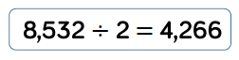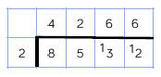
Year 6 | Divide multi-digits by 2-digits (short division) | When children begin to divide up to 4-digits by 2-digits, written methods become the most accurate as concrete and pictorial representations become less effective. | Children can write out multiples to support their calculations with larger remainders.  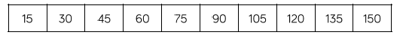 | 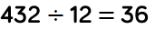  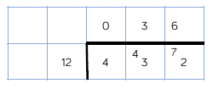  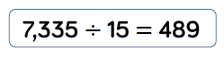  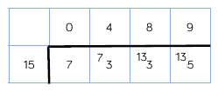
Year 6 | Divide multi-digits by 2-digits (long division) |  | 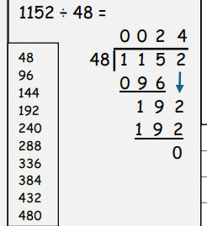 | 